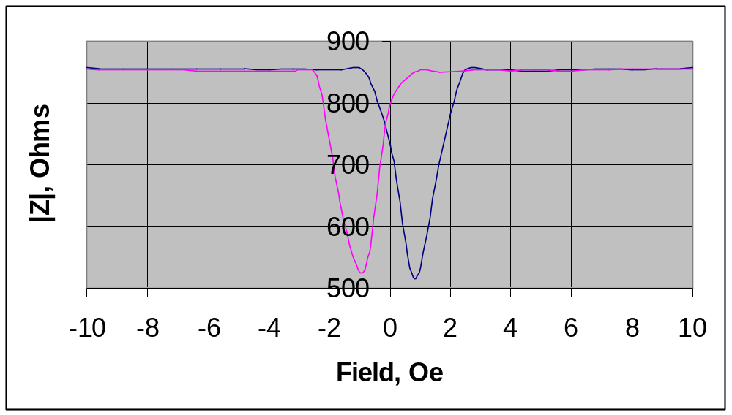
Fig.1 Impedance module vs field for 5 GHz.

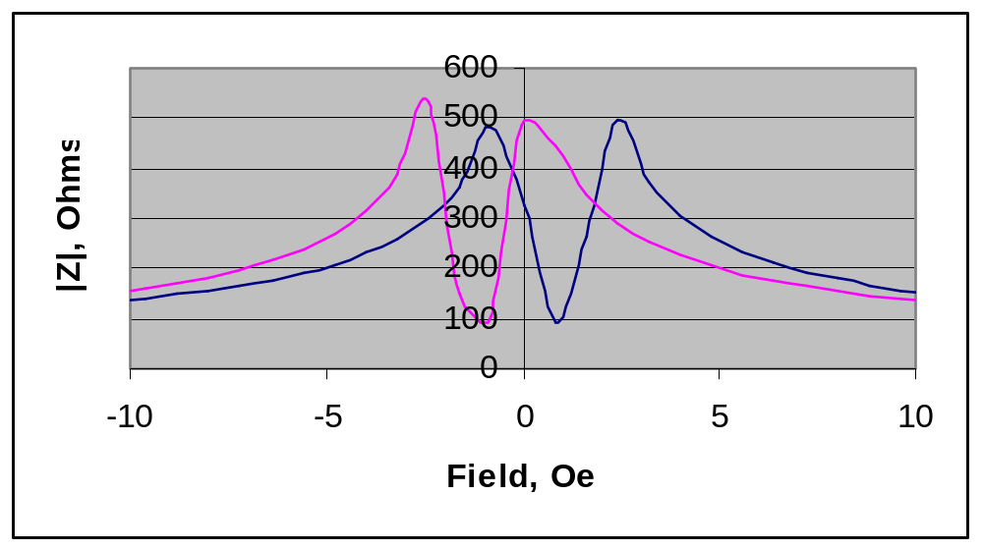
Fig.1 Impedance module vs field for 10 MHz.

